|  |  |  |
| --- | --- | --- |
| 10101010101010101010101010101010101010101010101010101010101010101010101010101010101010101010101010101010101010101010101010101010101010  01010101010101010101010101010101010101010101010101010101010101010101010101010101010101010101010101010101010101010101010101010101010101 | | |
| 1010  0101 1010  0101 | Ind. Study / Practicum  Project: Simon Game | 1010  0101  1010  0101 |
| 10101010101010101010101010101010101010101010101010101010101010101010101010101010101010101010101010101010101010101010101010101010101010  01010101010101010101010101010101010101010101010101010101010101010101010101010101010101010101010101010101010101010101010101010101010101 | | |

**How the game works?**

This game is based on the kid’s game named “Simon Says”. The objective of the game is to repeat the longest pattern of sounds or clicks.

Below is a screenshot of the game interface. You will make a similar interface, but you need to add a instructions section on how to play the game. Also, instead of starting the game by pressing any game you will include a START button to stay the play.

Game is load Game is on level 2

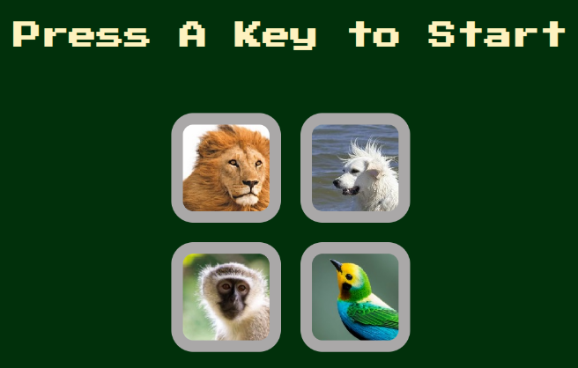 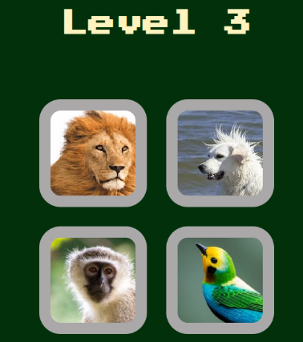

The above screenshot does not show the instruction and the button to start the game. Use your creativity to incorporate both items.

Stage 1

For this stage of the game you need to present the basic skeleton of the layout as shown in the following picture:

